Pad Valve Unit (PVU) Theory of Ops

Valve Sheets

TPS259830
12V UVLO and OVLO resistors. R1 = 1M, R2 = 22k, R3 = 100k
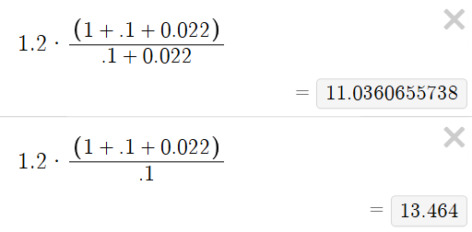
24V UVLO and OVLO resistors. R1 = 1M, R2 = 8.2k, R3 = 49.9k
